**Lab – 18: Creating a new label for protection, visual markers, and a condition to prompt for classification.**

**Objective:** The objective of this lab is –

* To create a new label for protection, visual markers, and a condition to prompt for classification.

In this lab, we are going to create a new sub-label for **Confidential**.

**Prerequisite:** EMS Enterprise Mobility + Security E5.

**Steps:**

1. Sign in to your Azure Portal, by using the link - **https://portal.azure.com/**. Enter your credentials and click Sign In.

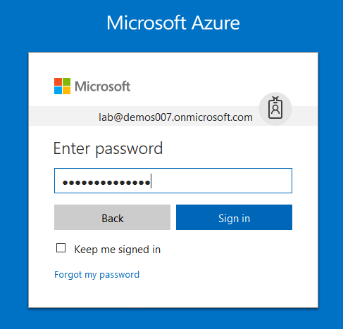

1. Microsoft Azure AD Dashboard will open.

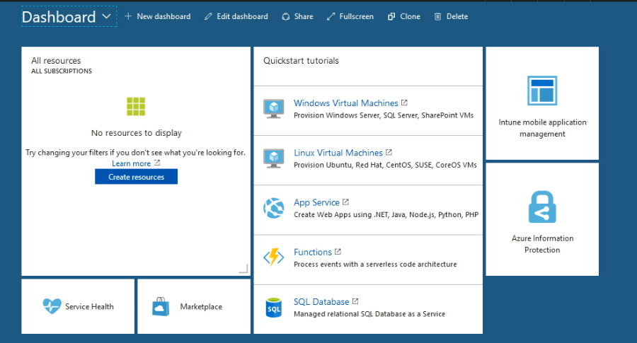

1. Click **Azure Information Protection** from the Dashboard menu.
2. Then in Azure Information Protection select **Global policy** to open the **Policy: Global blade**. This blade automatically opens for subsequent connections to the service and it displays the default Information Protection policy that's created for your tenant.
3. Right-click the **Confidential** label, and select **Add a sub-label**. If you do not have a label named Confidential, you can select another label.

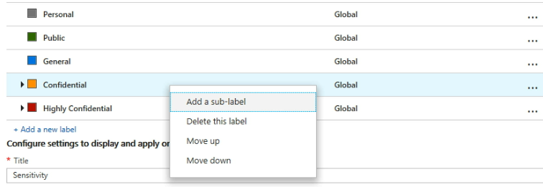

1. On the Sub-label blade, specify the **label name** of Educationa and add the description: **Confidential data that contains educational information that is restricted to employees only**.This text describes how the selected label is intended to be used and it is visible to users as a tooltip, to help them decide which label to select.
2. For **Set permissions for documents and emails containing this label**, select **Protect**, and then select **Protection**. Click on the **Protection** blade. You will get options **Azure (cloud key)** and **HYOK (AD RMS)** this is Hold Your Own Key. You must activate the protection service before you can configure labels for Azure (cloud key) protection. You can configure as per your choice then click **OK**. Here, **Azure (cloud key)** is selected. This option uses the Azure Rights Management service to protect documents and emails. You can make it **Not configured** or **Rmove Protection** also.

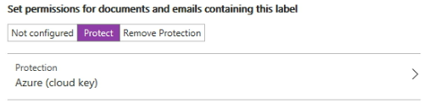

1. Then, locate the **Set visual marking** section:

For the **Documents with this label have a header** setting, click **On**, and then in the Text box, type **Classified as Confidential**. Give Header font size: 12 and Header color: Red.

For the **Documents with this label have a footer** setting, click **On**, and then in the Text box, type **Microsoft**. Give Footer font size: 12 and Fotor color: Red

For the **Documents with this label have a watermark** setting, click **On**, and then in the Text box, type your organization name. For example, Microsoft.

So, you can change the appearance for these visual markers.

1. Locate the section **Configure conditions for automatically applying this label**:

Click **Add a new condition** and then, on the **Condition blade**, select the following:

a. Choose the **type of condition**: Keep the default of **Information Types**.

b. In the **Select information types** search box: Type **credit card number**. Then, from the search results, select **Credit Card Number**.

c. **Minimum number of occurrences:** Keep the default of **1**.

d. **Count occurrences with unique values only:** Keep the default of **Off**.

Click **Save** to return to the **Sub-label** blade.

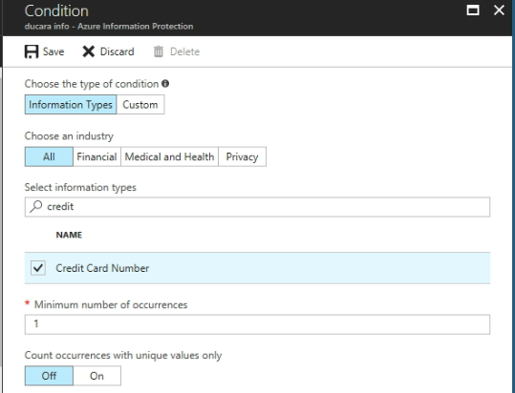

1. On the **Sub-label** blade, you see that **Credit Card Number** is displayed as the **CONDITION NAME**, with **1 OCCURRENCES**:

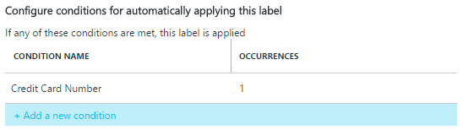

1. For **Select how this label is applied**: Keep the default of **Recommended**, and do not change the default policy tip.
2. In the **Enter notes for internal housekeeping** box, type **For testing purposes**.
3. Click **More** from the top-right corner on this Sub-label blade and click **Save**.
4. Then, on the Policy: Global blade, you now see your new sub-label, which is configured for visual markings and protection under **Confidential**.

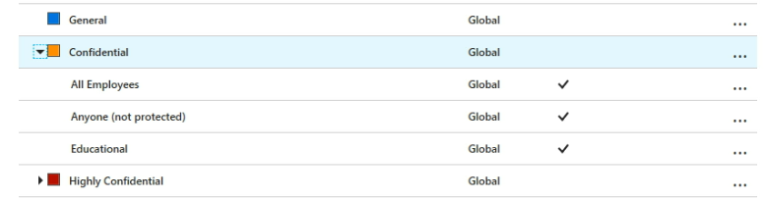

1. Now that we've made our changes, we want to make them available to users, so click **Publish**, and click **Yes to confirm**.

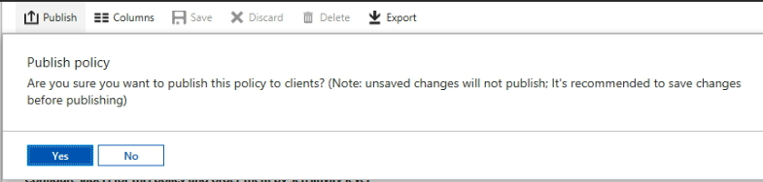

1. So, in this way you can create a new label for protection, visual markers, and a condition to prompt for classification.